TECHNICAL DATA SHEET
NON WOVEN - ISOLATION GOWNS
ISO25-BLUE
Intended Use
Non-surgical, procedural Isolation Gown: intended to protect health care patients and personnel from the transfer of microorganisms, particulate material. Single use and disposable. Non Sterile, Latex Free

CHARACTERISTIC | SPECIFICATION
Description | Gown made of non-woven fabric with tie neck, tie back, Sleeves with elastic wrist. Non Sterile
Material Composition | Spun bonded Polypropylene, Latex Free, 25 grams
Dimensions | See Table below
Packing Way | 10 pcs bag/ 10 bags case = 100 pcs per case
Style Numbers | ISO25-BLUE
SIZING | OSFA
Storing | Store under ambient temperature and dry conditions.

DESCRIPTION | DIMENSION/ SIZE in (cm)
Gown Length | 120
Underarm Width | 73
Sleeve Length | 58
Shoulder Height (from underarm until shoulder) | 25
Shoulder Width (from neck hole to shoulder) | 23
Collar Depth | 9
Collar Width | 25
Sleeve Cuff Width | 8
Sleeve Cuff Width (Stretched) | 16
Width of Gown | 145
Tie Back | At neck and waist
Carton Size | 56*26*31cm
Weight per carton | 5.5/6.0 kg
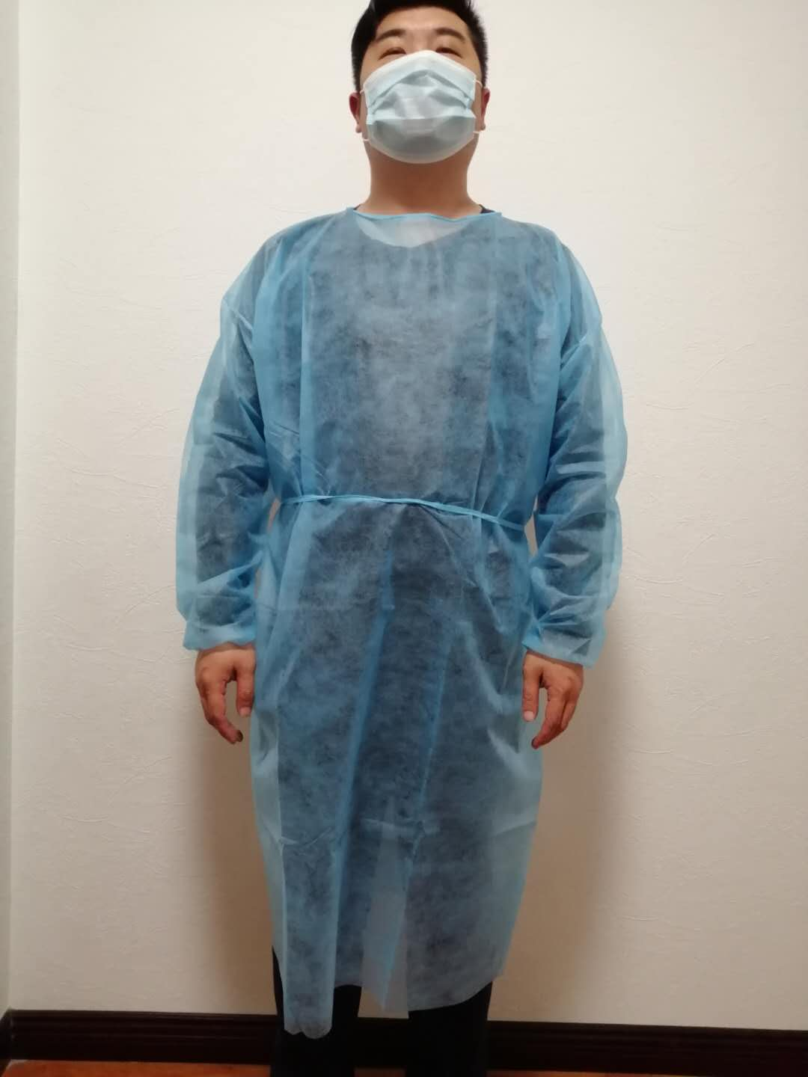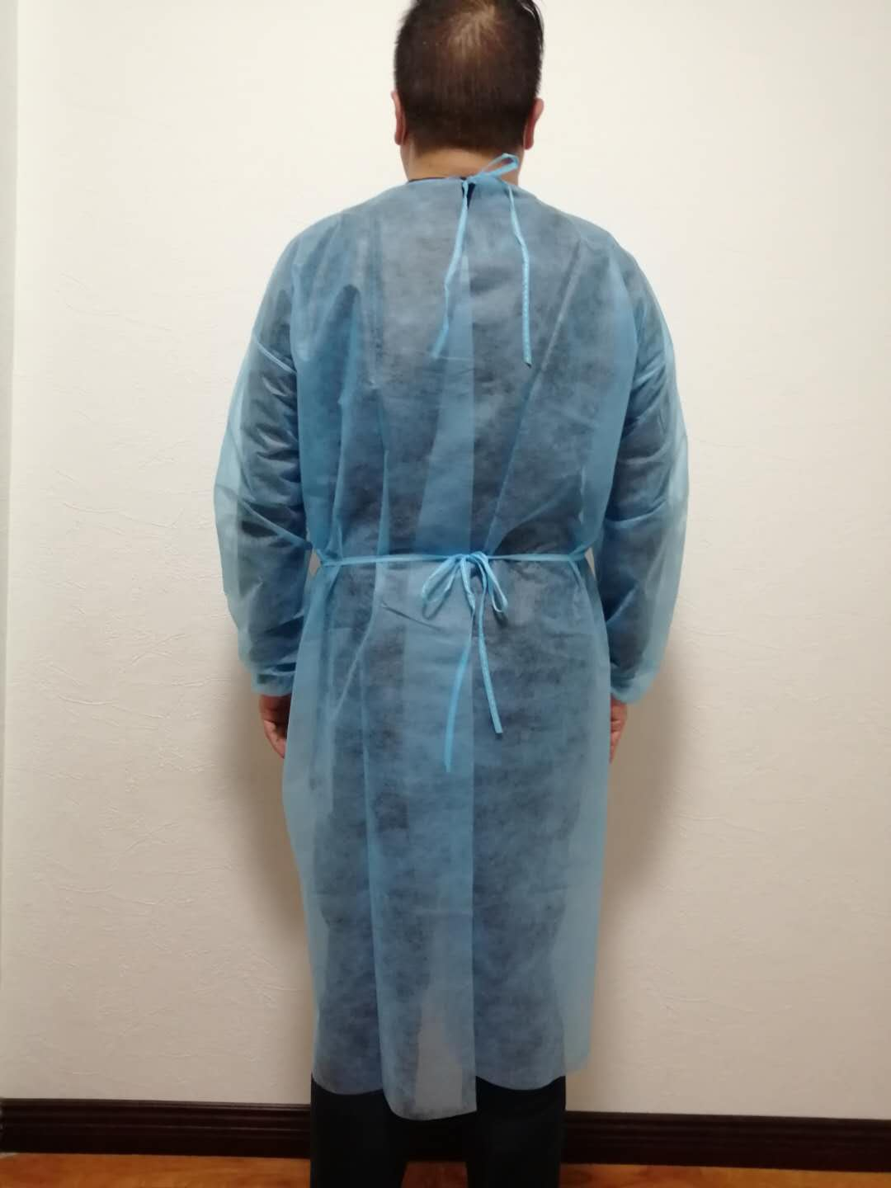
LOT 80988

