Complies with OSHA’s Hazard Communication Standard 2012 and the Global Harmonized Standard (GHS).

_____ Page 1 of 5
Section 1 : Identification
Product Identification: MARK3 Tarter, Stain & Permanent Cement Remover

Distributed by: Cargus International, Inc.
135 North Route 9W, Congers, NY 10920
Telephone: 845-267-2600
Email: ggabai@cargus.com
Emergency Telephone: National Capital Poison Center 1-800-222-1222

Recommended use: Rapid ultrasonic cleaning of certain dental instruments/appliances.

Section 2 : Hazard(s)

Classification of the substance or mixture:

GHS Classification in accordance with 29 CFR 1910 (OSHA HCS)
Skin irritation (Category 2)
Eye irritation (Category 1)
Aquatic toxicity (Category 3)

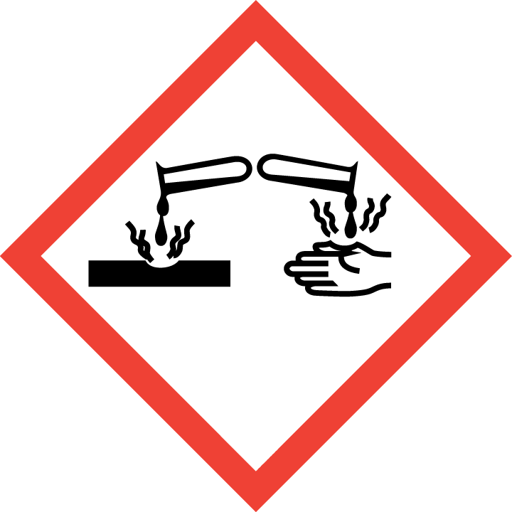 Danger 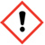

Hazard Statements

H303 May be harmful if swallowed
H315 Causes Skin Irritation
H318 Causes serious eye damage
H402 Harmful to aquatic life

Precautionary Statements

P280 Wear protective gloves/protective clothing/eye protection/face protection
P305+P351+338 IF IN EYES: Rinse cautiously with water for several minutes. Remove contact
lenses if present and easy to do – continue rinsing.
P310 Eye irritation: Immediately call Poison Center or doctor or physician.
P352 For skin: Wash with plenty of soap and water

Hazard Summary: Product contains sulfamic acid and anionic surfactant. Intended Use: Professional Use Only rapid ultrasonic cleaning of certain dental instruments/appliances.

Section 3 : Composition / information on Ingredients
Hazardous Ingredient(s) CAS # Exposure PEL, TLV, TWA %

Sulphamidic acid 5329-14-6 1 mg/m3 OSHA PEL < 10
Sodium 2-ethylhexyl sulfate 126-92-1 NE < 1

Complies with OSHA’s Hazard Communication Standard 2012 and the Global Harmonized Standard (GHS).

_____ Page 2 of 5
Product Identification: Tartar & Stain Remover Liquid

Section 4 : First-aid measures

EMERGENCY FIRST AID PROCEDURES
Eye Contact: Check for and remove any contact lenses. Immediately flush eyes with running water for at least 15 minutes, keeping eyelids open. Cold water may be used. Do not use an eye ointment. Seek immediate medical attention.
Skin Contact: If the chemical got onto the clothed portion of the body, remove the contaminated clothes as quickly as possible, protecting your own hands and body. Place the victim under a deluge shower. If the chemical got on the victim's exposed skin, such as the hands : Gently and thoroughly wash the contaminated skin with running water and non-abrasive soap. Be particularly careful to clean folds, crevices, creases and groin. Cold water may be used. If irritation persists, seek medical attention. Wash contaminated clothing before reusing.
Serious Skin Contact: Wash with a disinfectant soap and cover the contaminated skin with an anti-bacterial cream. Seek immediate medical attention.
Inhalation: Allow the victim to rest in a well ventilated area. Seek immediate medical attention.
Serious Inhalation: Evacuate the victim to a safe area as soon as possible. Loosen tight clothing such as a collar, tie, belt or waistband. If breathing is difficult, administer oxygen. If the victim is not breathing, perform mouth-to-mouth resuscitation. WARNING: It may be hazardous to the person providing aid to give mouth-to-mouth resuscitation when the inhaled material is toxic, infectious or corrosive. Seek immediate medical attention.
Ingestion: Do not induce vomiting. Give large quantities of water or milk. Loosen tight clothing such as a collar, tie, belt or waistband. If the victim is not breathing, perform mouth-to-mouth resuscitation. Seek immediate medical attention.

Section 5 : Fire-fighting measures

Flash Point : Not flammable Flammable limits : N/A LEL : N/A UEL : N/A

Extinguishing media: Not flammable. Unusual fire and explosion hazards: None

Special Fire Fighting Procedure: Product not flammable. No special requirements.

Section 6 : Accidental release measures

Personal precautions: Use personal protection per Section 8.
Small Spill: Use appropriate absorbent material to soak up spill. Put the solid waste in a convenient waste disposal container. If necessary: Neutralize the residue with a dilute solution of sodium carbonate.
Large Spill: Stop leak if without risk. Do not touch spilled material. Use water spray to reduce vapors. Prevent entry into sewers, basements or confined areas; dike if needed. Use appropriate absorbent material to soak up spill. Call for assistance on disposal. Neutralize the waste material with a dilute solution of sodium carbonate.
Section 7 : Handling and storage

Keep container dry. Do not ingest. Do not inhale vapors. In case of insufficient ventilation, wear suitable respiratory equipment.
If ingested, seek medical advice immediately and show the container or the label. Avoid contact with skin and eyes
Handling: Use in well ventilated areas. Avoid contact with eyes.

Advice on protection against fire and explosion: Product is not flammable.

Storage: Store in well ventilated areas at ambient temp.

Advice on common storage: Do not store next to strong reducing agents, halogens or peroxides.

Complies with OSHA’s Hazard Communication Standard 2012 and the Global Harmonized Standard (GHS).

__ _______ Page 3 of 5
Product Identification: Tartar & Stain Remover Liquid

Section 8 : Exposure control / personal protection

Engineering Measures: Provide normal room ventilation.

Personal Precautions: Use protective clothing as specified below.

Eye Protection: Use safety goggles or approved safety glasses.

Hand Protection: Use protective gloves and discard after contact with product. Latex gloves are not a chemical
barrier.

Skin and body protection: Pants, long sleeves, clinical jacket.

Respiratory protection: Use minimum of a clinical face mask if adequate room ventilation is present.

Hygiene measures: Wash hands after using. Emergency eye wash station must be available.

Launder contaminated clothing.

Exposure Guidelines: None determined.

Respiratory protection: Not normally required as long as adequate room ventilation is present.
Hygiene measures: Wash hands after using. Emergency eye wash station must be available. Launder contaminated clothing.

Section 9 : Physical chemical properties

Boiling Point : Approx 105 C Specific Gravity : 1.10 Vapor Pressure: (mm Hg) N/A

Evaporation Rate : (n-butyl = 1) Approx 1 Vapor Density : (Air = 1) 1.105 @ 15 C

Solubility in Water : Complete pH: < 1

Appearance and Odor: White to slightly yellow powder with slightly sulfurous, irritating odor.

Section 10 : Stability and reactivity

Materials to avoid: Avoid contact with strong reducing agents, halogens and peroxides.

Hazardous decomposition products: Combustion may produce carbon monoxide and carbon dioxide, sulfur and nitrogen oxides.

Hazardous reactions: Will violently evolve gases if mixed with strong reducing agents, halogens, peroxides.

Do not mix with other chemicals.

Section 11 : Toxicological information
Acute oral toxicity: Anionic surfactant = LD₅₀ > 1310 mg/kg (rat)

Sulphamidic acid = LD50 - rat - 3,160 mg/kg (OECD Test Guideline 401)

Not listed as a carcinogen by OSHA, IARC, AGCIH, or NTP.

Complies with OSHA’s Hazard Communication Standard 2012 and the Global Harmonized Standard (GHS).

__ _______ Page 4 of 5
Product Identification: Tartar & Stain Remover Liquid

Section 12 : Ecological information

Toxicity to fish static test

LC50-Pimephales promelas (fathead minnow) - 70.3 mg/l-96h (OECD Test Guideline 203)

Section 13 : Disposal consideration

Waste/Disposal Information: Observe all Federal, State, and Local Environmental Regulations when disposing
of this product.

Use and or alterations to this product such as mixing with other materials/chemicals may significantly change
the characteristics of the material and alter product hazard classifications and the proper disposal method.

Section 14 : Transport information

Product is classified as a Hazardous Material:

DOT Classification: CLASS 8: Corrosive Solution
Identification: Sulfamic acid :
UN2967
PG: III
Limited Quantity Exception for shipping : 173.154 Exception for Class 8 (corrosive materials) subpart b (2).

Section 15:

Federal and State Regulations: TSCA 8(b) inventory: Sulfamic acid

Section 15 : Regulatory information
SARA 302 Components:

SARA 302: No chemicals in this material are subject to the reporting requirements of SARA Title III, Section 302.

SARA 313 Components:

SARA 313: This material does not contain any chemical components with known CAS numbers that exceed the threshold (De Minimis) reporting levels established by SARA Title III, Section 313.

SARA 311/312 Hazards: Acute Health Hazard

Massachusetts Right To Know: No components are subject to the Massachusetts Right to Know Act.

Complies with OSHA’s Hazard Communication Standard 2012 and the Global Harmonized Standard (GHS).

__ _______ Page 5 of 5
Product Identification: Tartar & Stain Remover Liquid

Section 15 cont--

Pennsylvania Right To Know Components: Sulphamidic acid CAS-No.5329-14-6 Revision Date 2007-03-01

New Jersey Right To Know Components: Sulphamidic acid CAS-No.5329-14-6 Revision Date 2007-03-01

California Prop. 65 Components:

This product does not contain any chemicals known to State of California to cause cancer, birth defects, or any other reproductive harm.

Section 16 : Other information
Date prepared: December 2018 Revision: 1.00B

Information contained herein is furnished without warranties of any kind. Users should consider these data only as supplements to other information obtained by them and must make independent determinations of completeness and suitability of information from all sources to ensure proper disposal and use of materials for the safety and health of both employees and customers.

